PERIAPICAL ABSCESS

Q What is a periapical abscess?

A A periapical abscess is an infection around the end (or apex) of a tooth root. The degree of infection in the abscess is divided into 3 groups: Acute (painful), Sub-Acute (discomfort), Chronic (painless). The degree of infection will change from one state to another, depending on other conditions around the tooth, and your general health.

Q Why does a periapical abscess form?

A This abscess forms when the nerve (or pulp) of the tooth dies. Infection enters the dead nerve, and spreads to the bone around the tip of the tooth.

Q Can it be treated?

A This type of abscess is treated using a process known as root canal treatment.

Q What does it involve?

A The aim of the treatment is to remove infection from the nerve canals inside the root of the tooth. The canals are then sealed to prevent re infection.

Q What if it happens again?

A This is unlikely but root canal treatment can be carried out again.

Q Is it expensive?

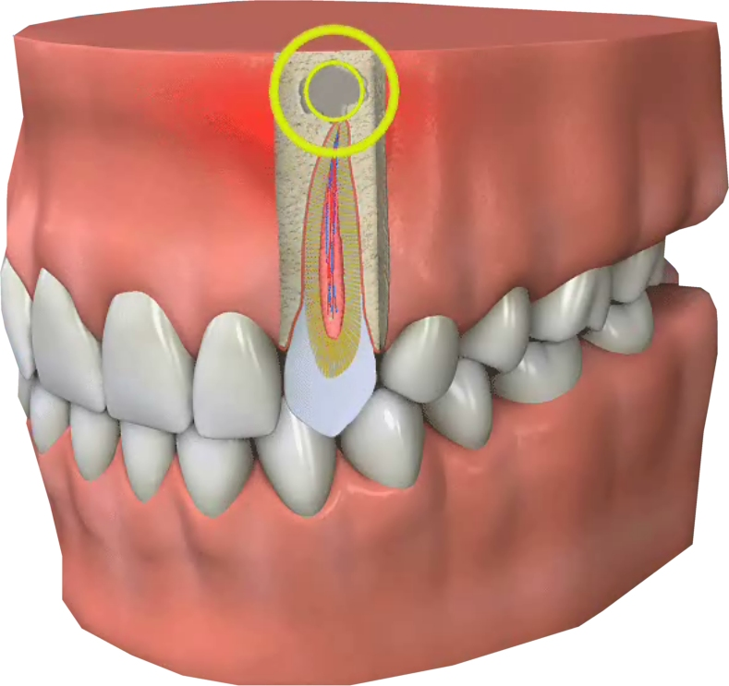
A Root canal treatment is a time consuming procedure, especially on the bigger back teeth called molars, which have a larger multi root system. You will need to discuss the cost with your dentist.

Q What if I don’t have the treatment?

A Sooner or later without treatment the tooth could become acutely infected (painful) or even have to be extracted.

Q Where can this treatment be carried out?

A Your family dentist will normally provide this treatment. Occasionally a specialist called an Endodontist will carry out the treatment.

Q What about aftercare?

A It is usually recommended that root filled teeth are crowned to prevent the tooth from splitting. This will add to the cost of saving the tooth.
